AWS-IAM
- Create one IAM user and assign EC2 and S3 full access roles.
First I have Navigated to IAM service, then clicked on users to create an user
- Enter username
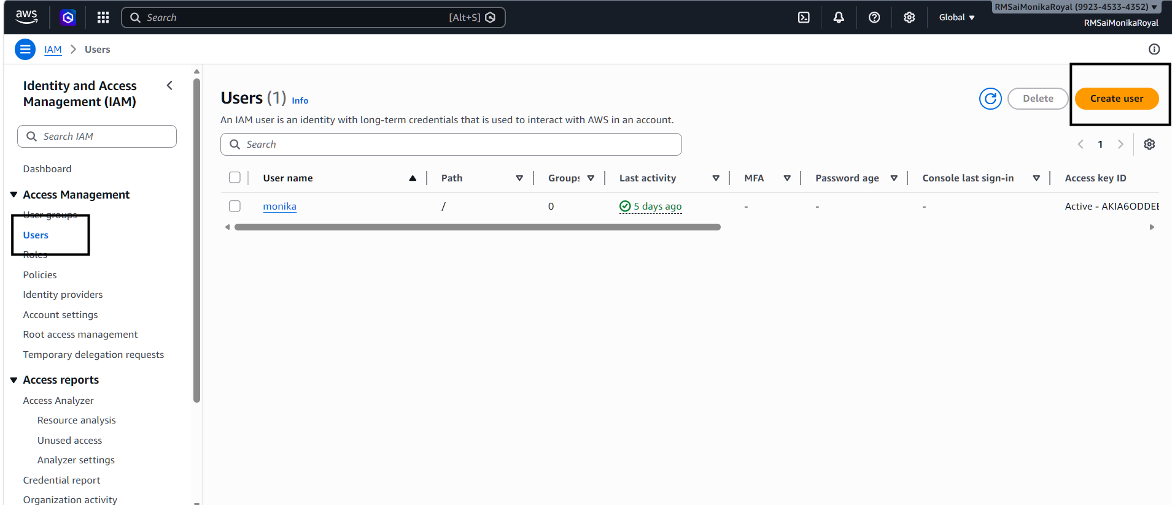
- I have enabled AWS Management Console access

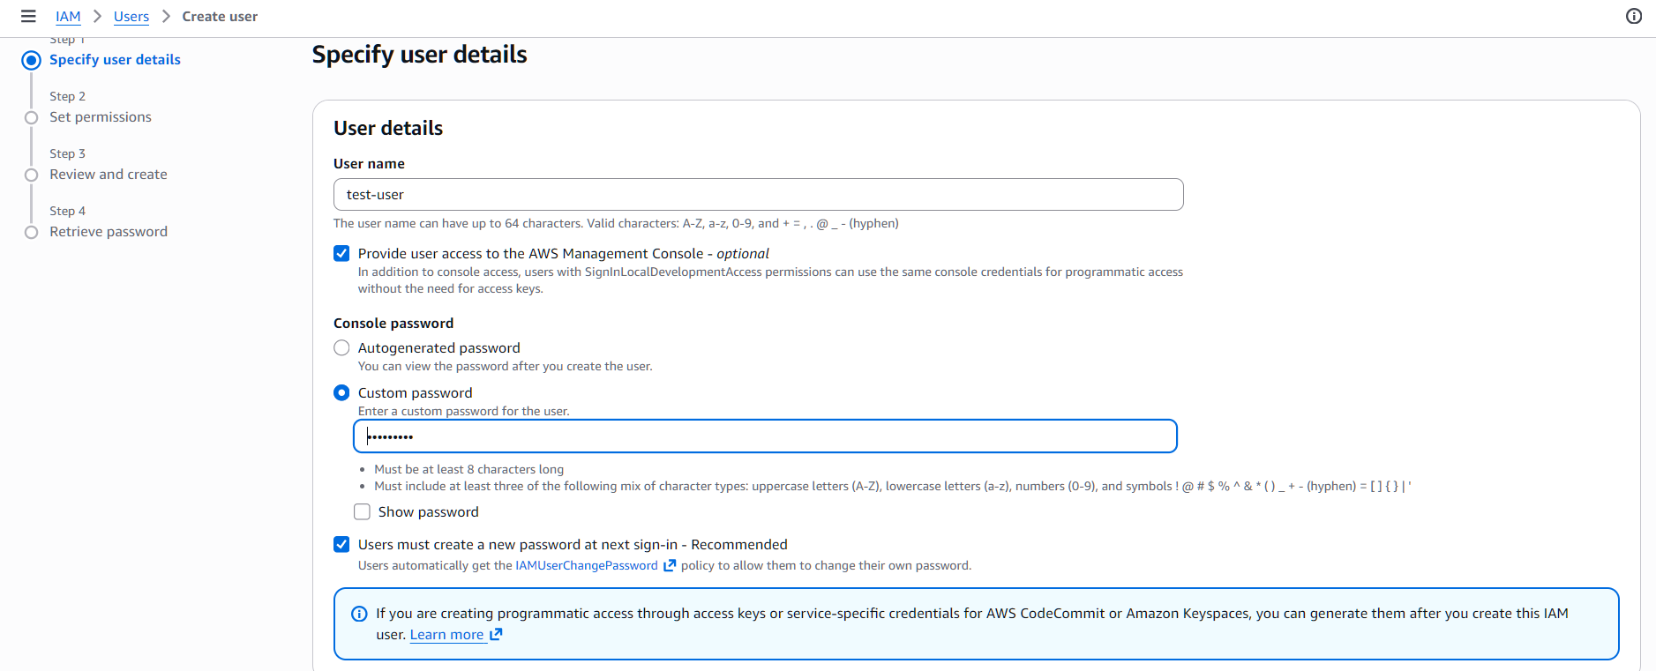
Set Permissions
- Select Attach policies directly
- Search and attach the following policies:
S3fullaccess
Ec2fullaccess

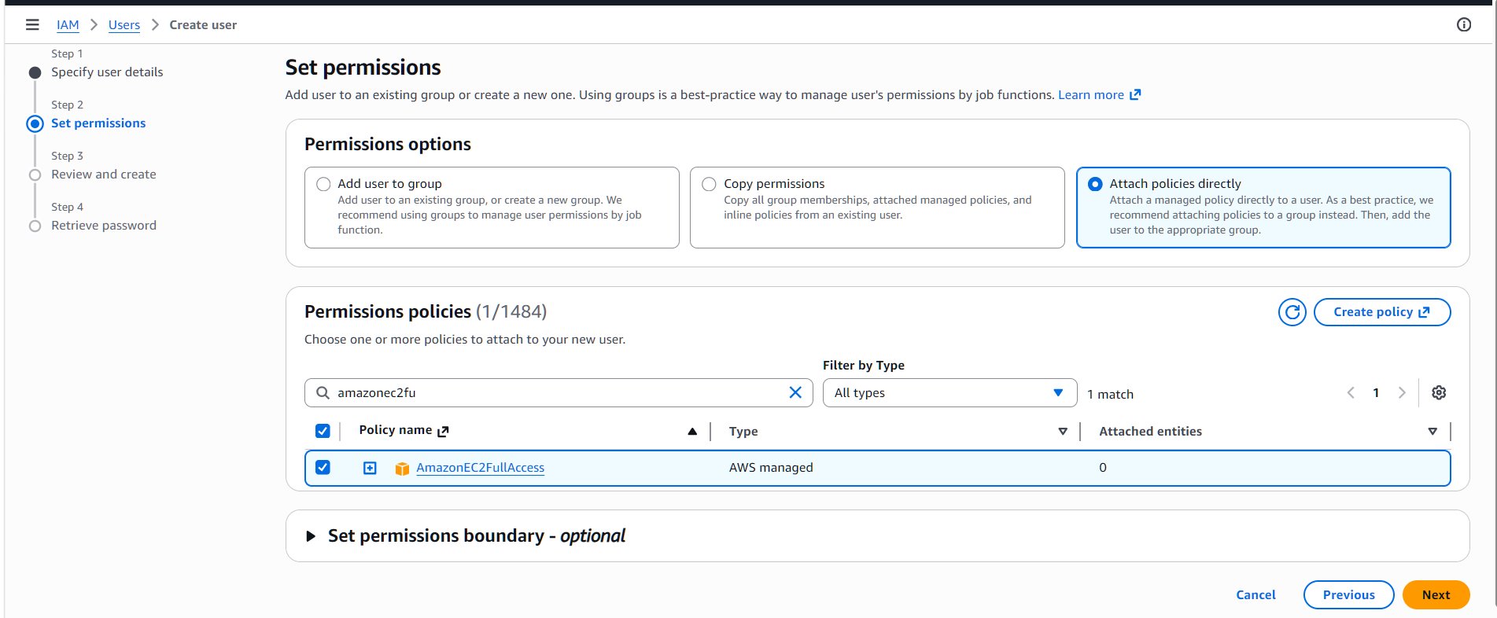
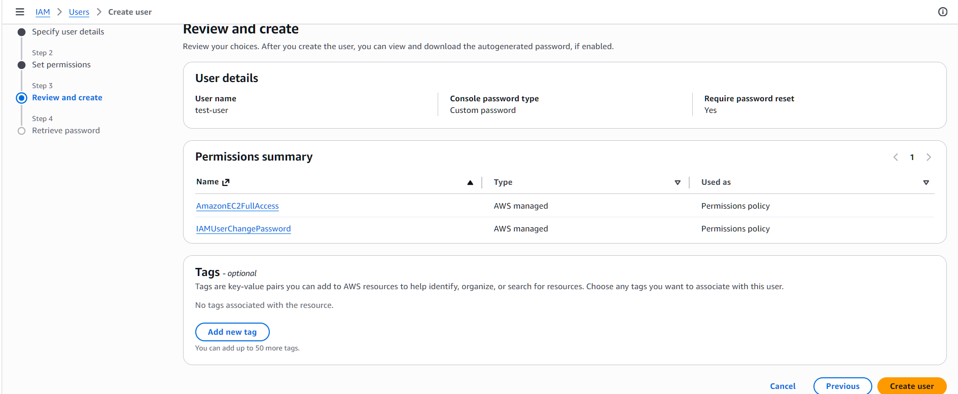
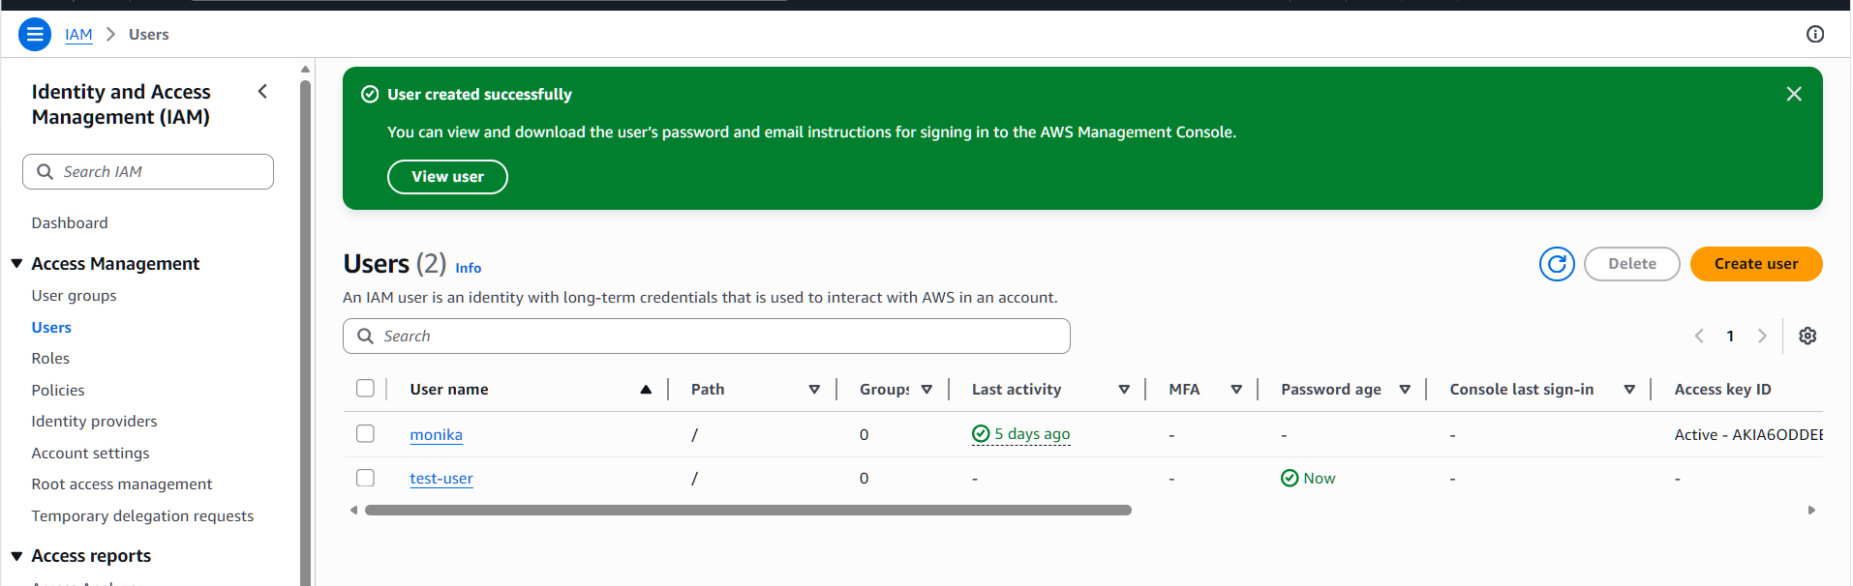
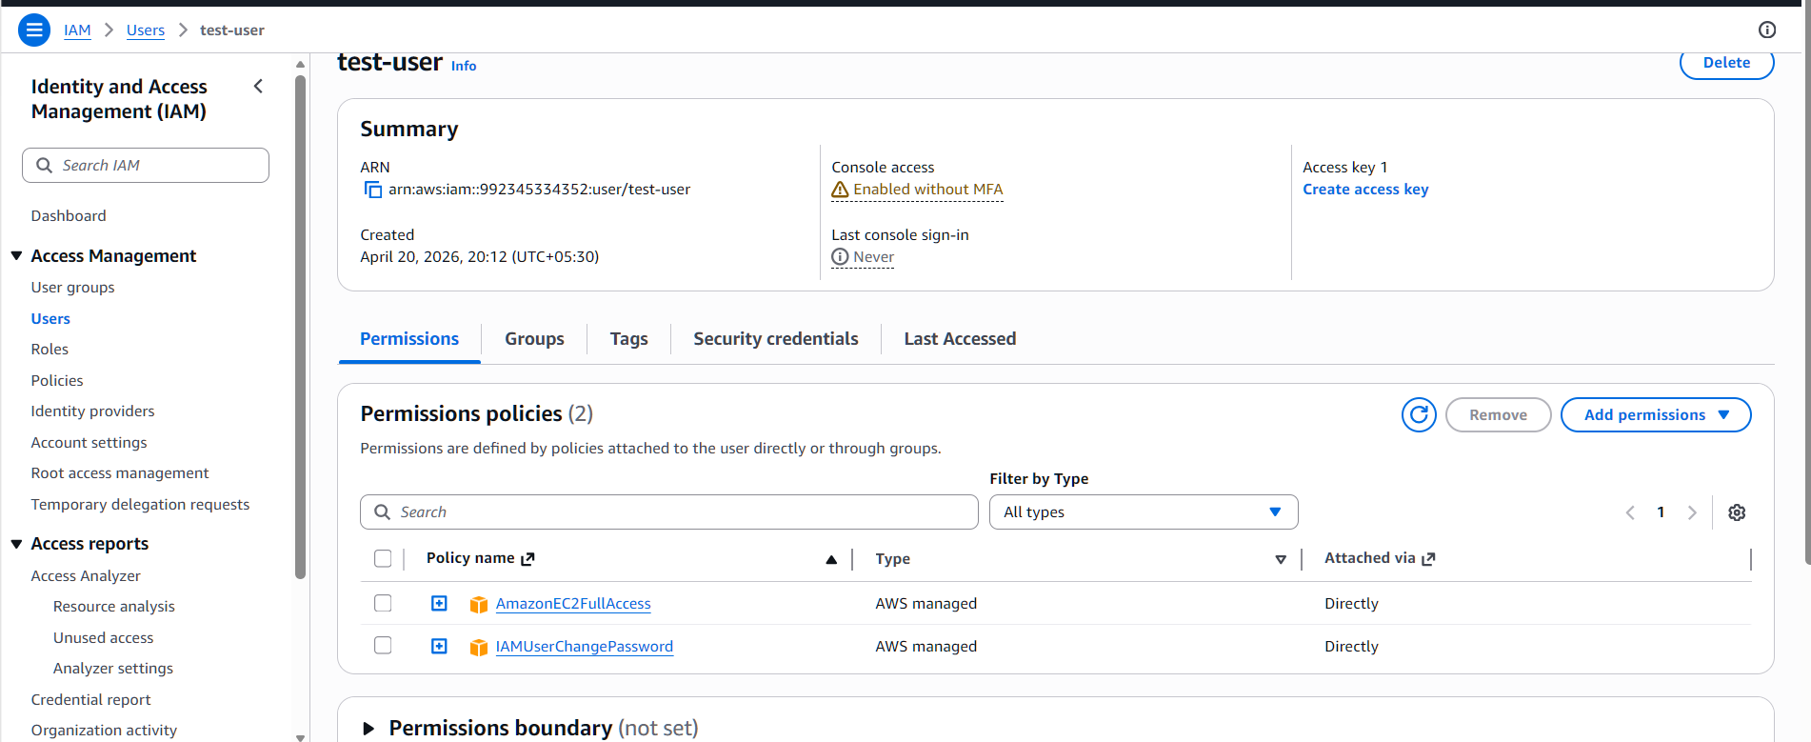
I have loginned to IAM user
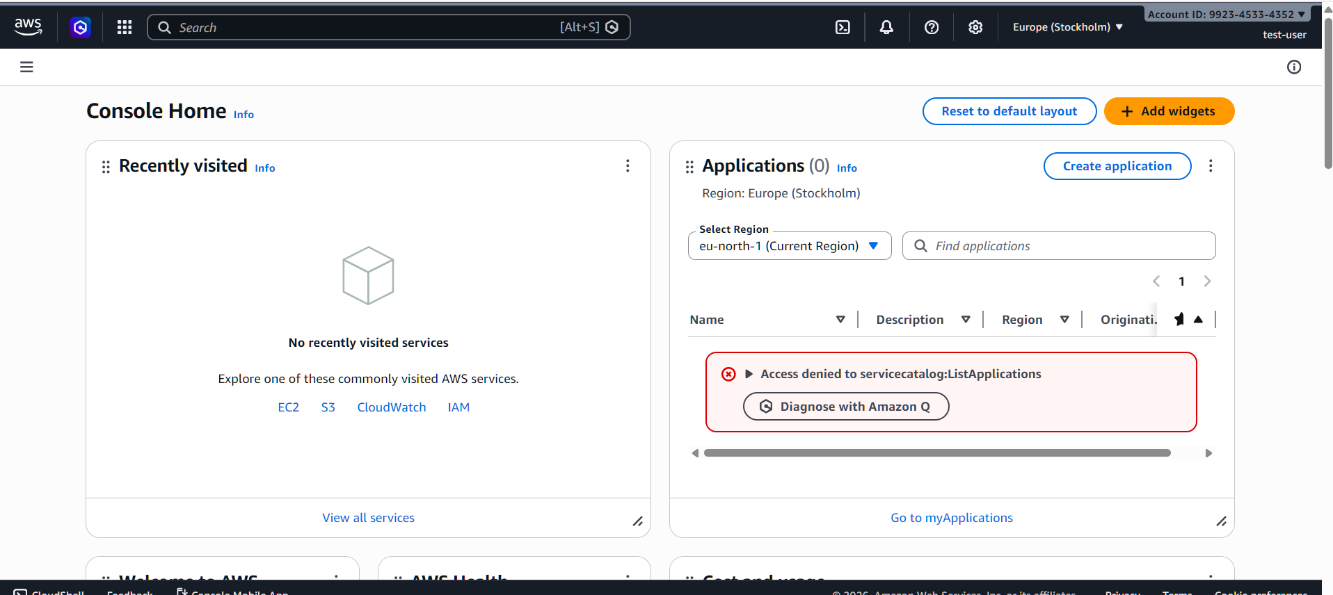
2.Create one group in IAM and assign read access for EC2
Create IAM Group
- In IAM Dashboard → Click User Groups
- Click Create group
- Enter group name
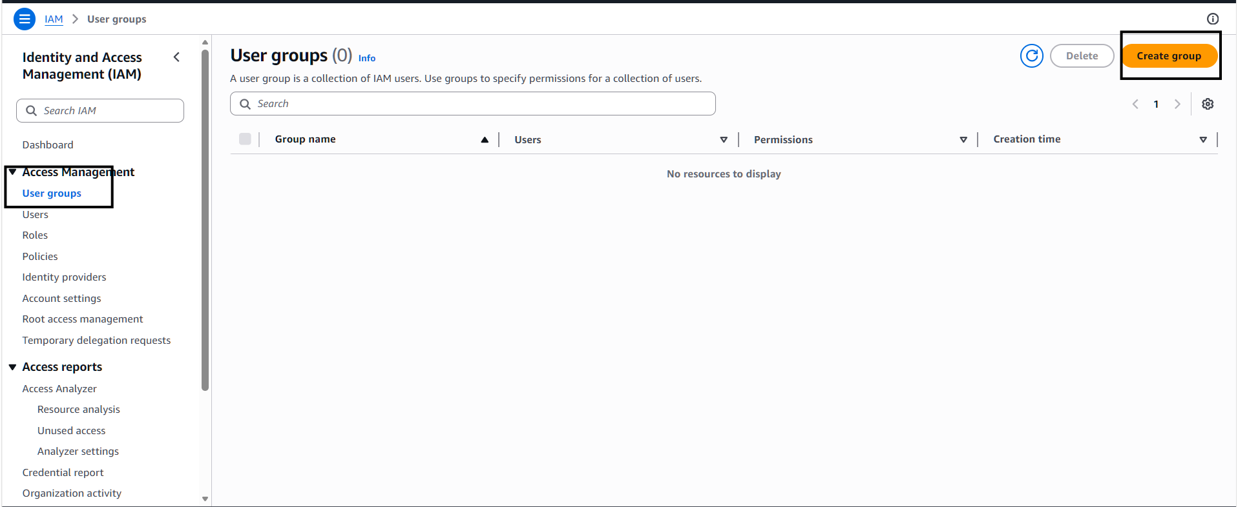
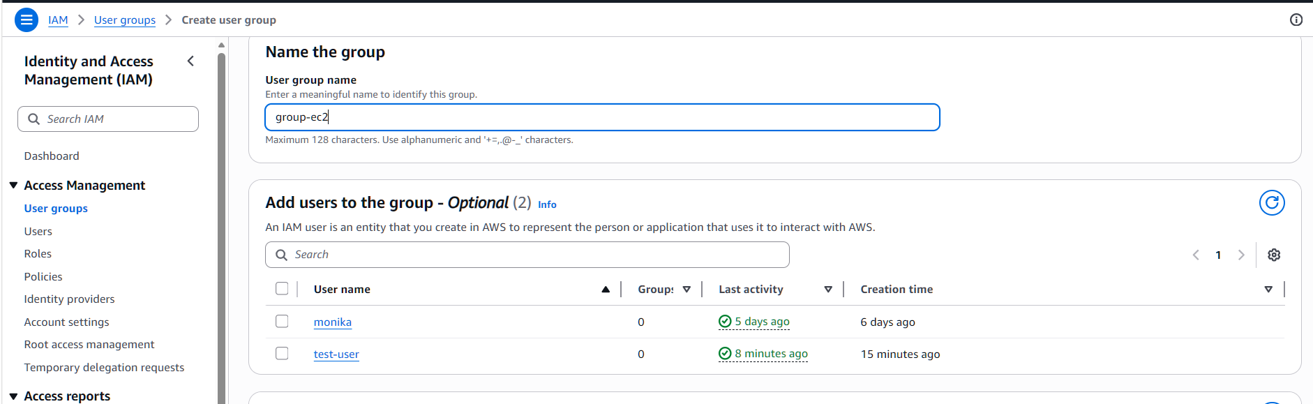
-Attach Permissions
1. Under Attach permissions policies
2. Search and select:
-AmazonEC2ReadOnlyAccess
This policy allows users to:
• View EC2 instances
• Check instance status
• View configurations and resources
• Cannot create, modify, or delete resources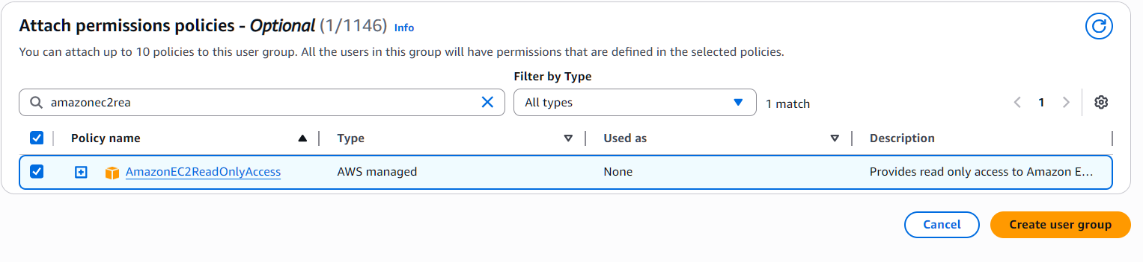
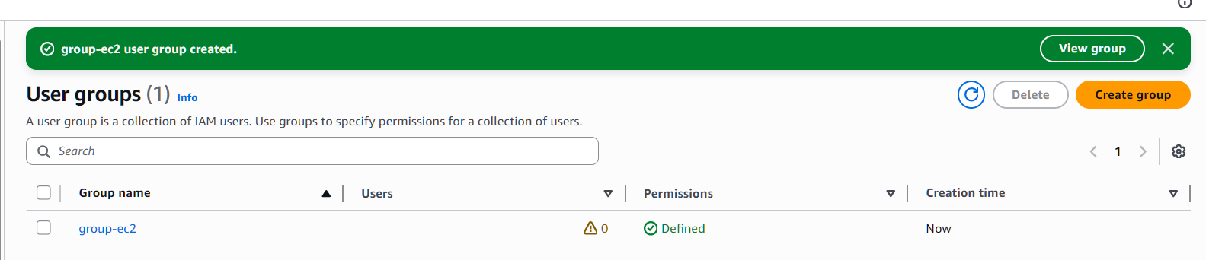
3.Create a new user named "Devops" and add to the group created in task 2.
Create New IAM User
- In IAM Dashboard → Click Users
- Click Create user
- Enter username: Devops
Select Access Type:
- Enable AWS Management Console access (for login)
- Click Next
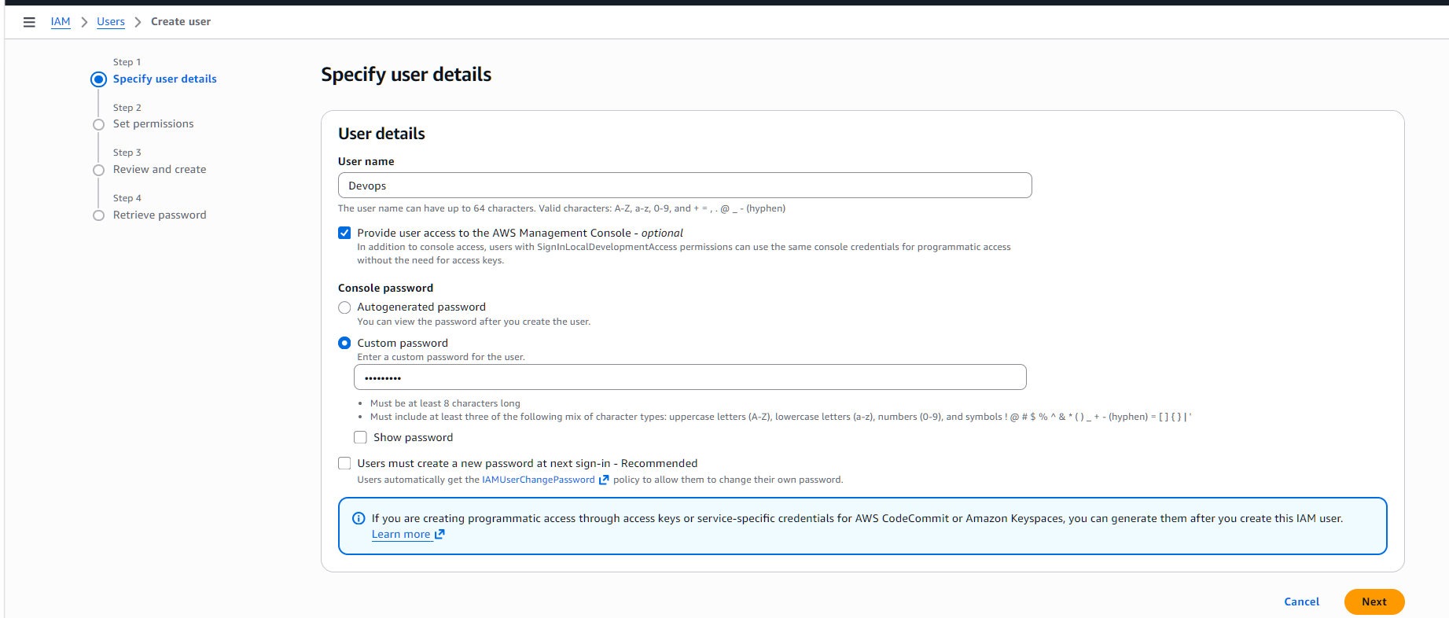
Here I am adding user to the existing group
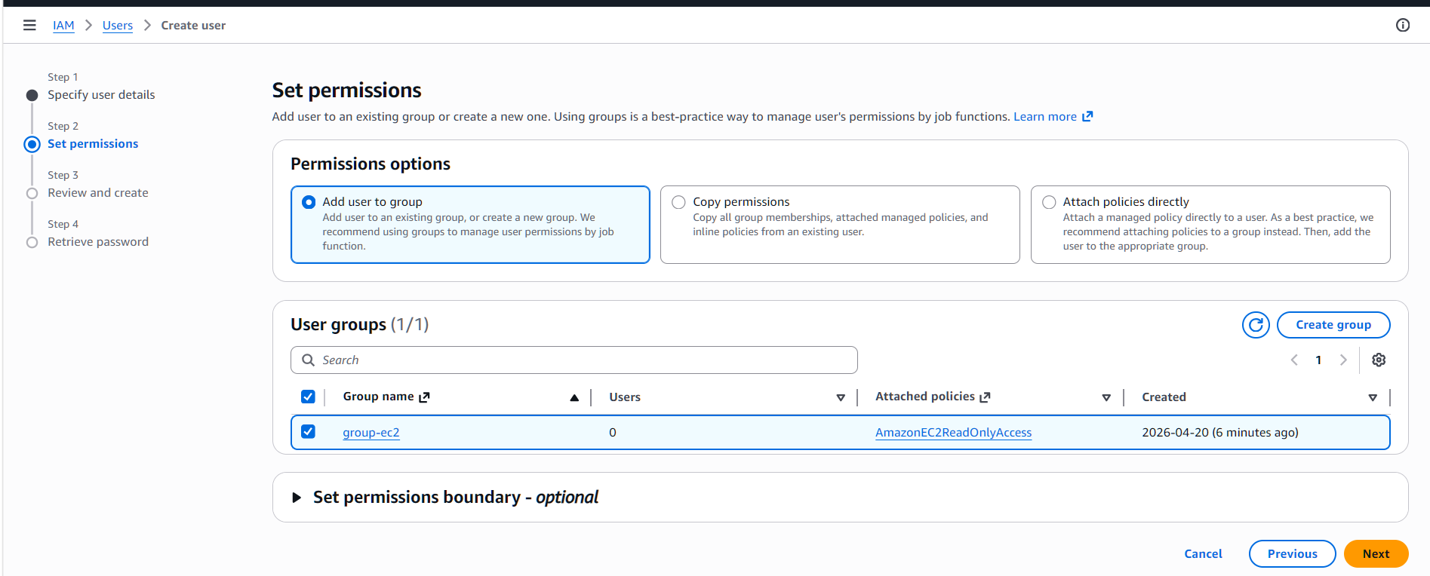
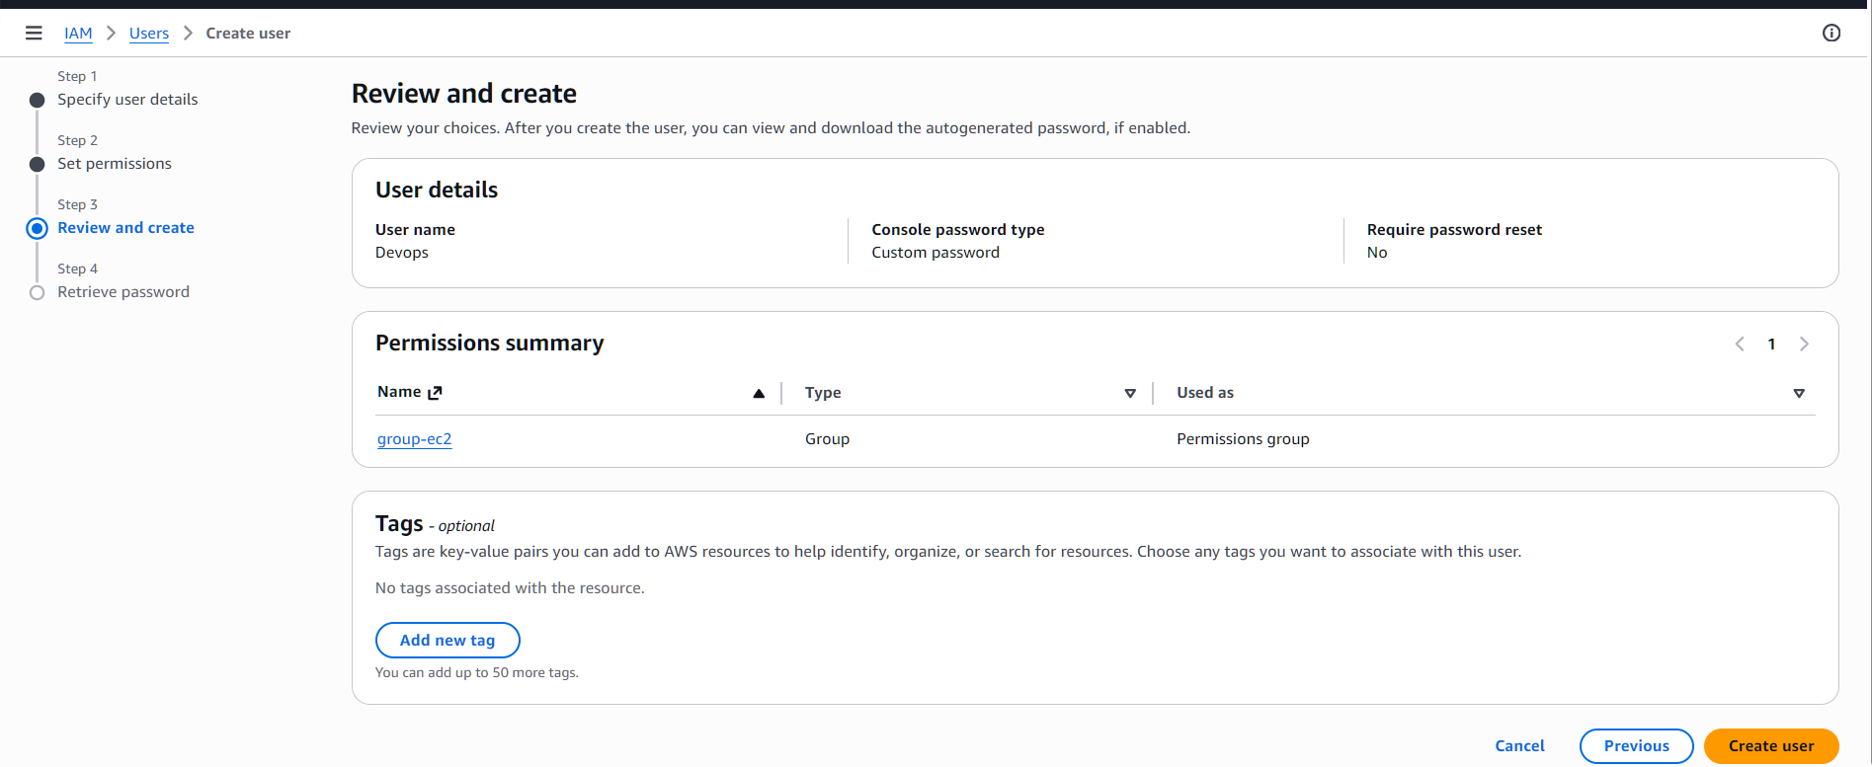
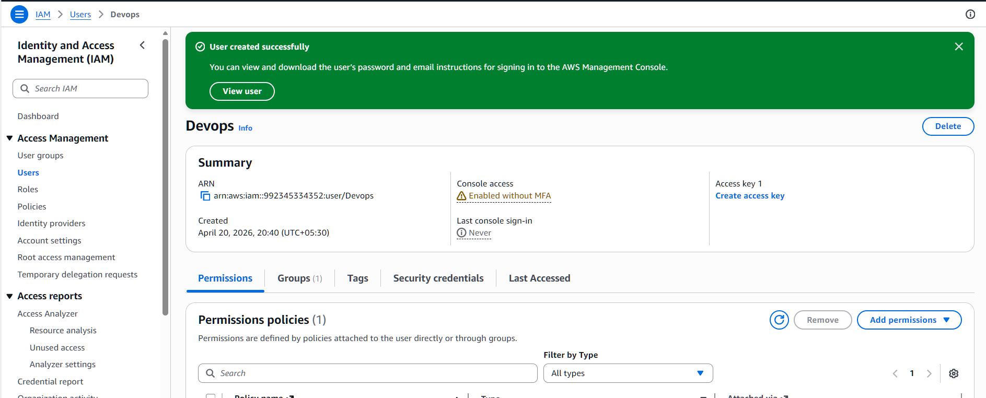
4.Write a bash script to create an IAM user with VPC full access.
I have created a file and wrote a bash script to create an IAM user with VPC full access
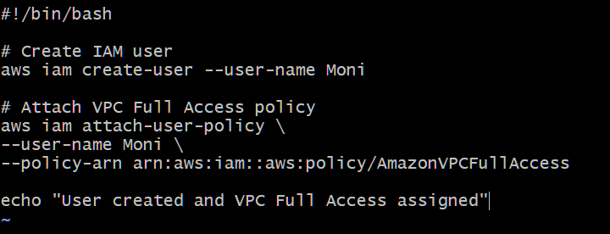
Allowed permissions to execute
Chmod +x
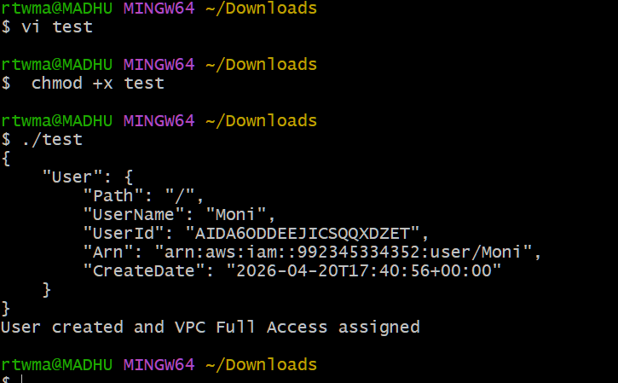
Checked whether the user is created or not
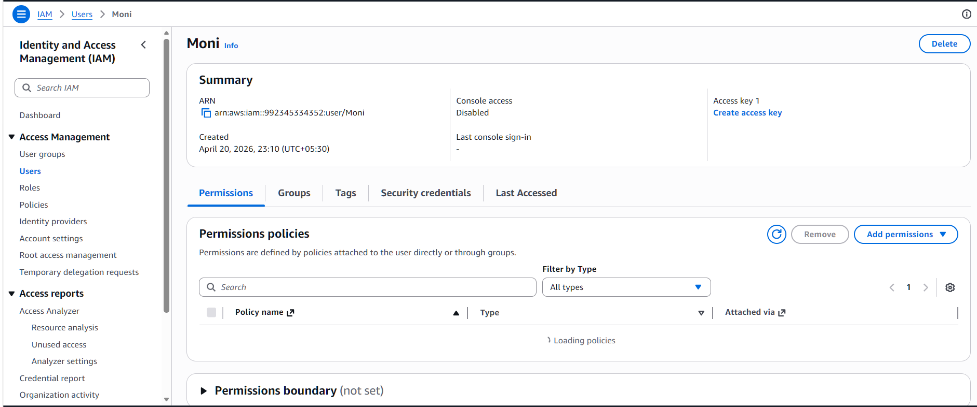
5. Create an IAM policy to allow EC2 access for a specific user in specific regions only.
First I have created policy
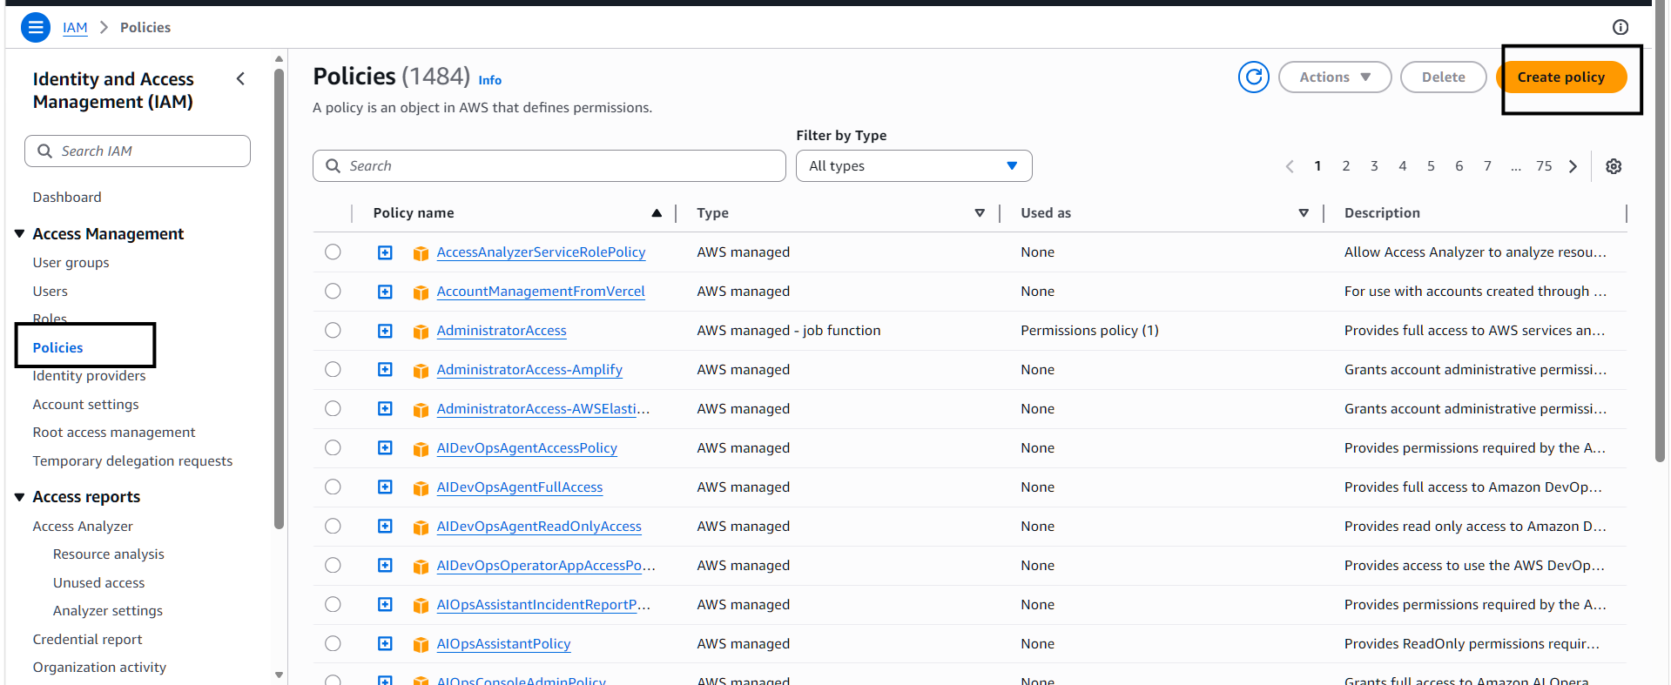
I have added json policy
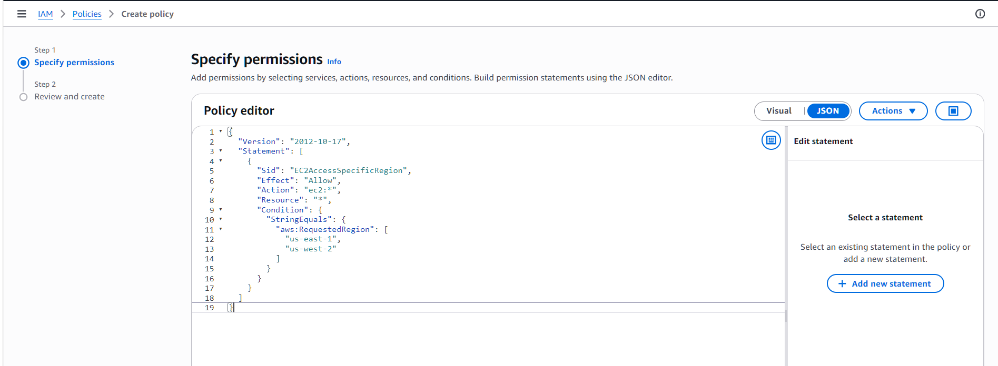
Here I have added a policy name
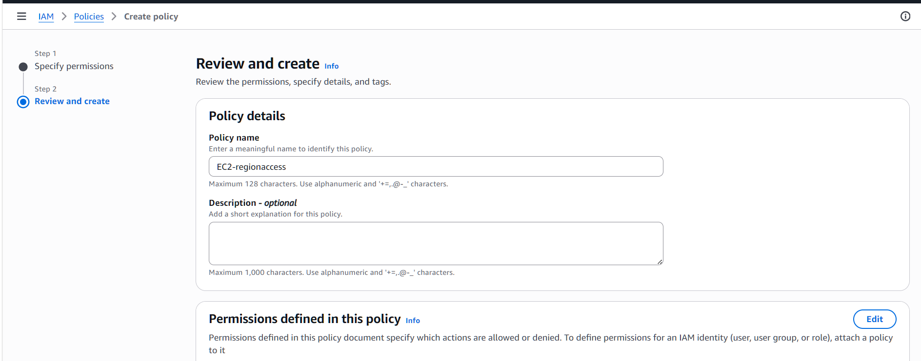
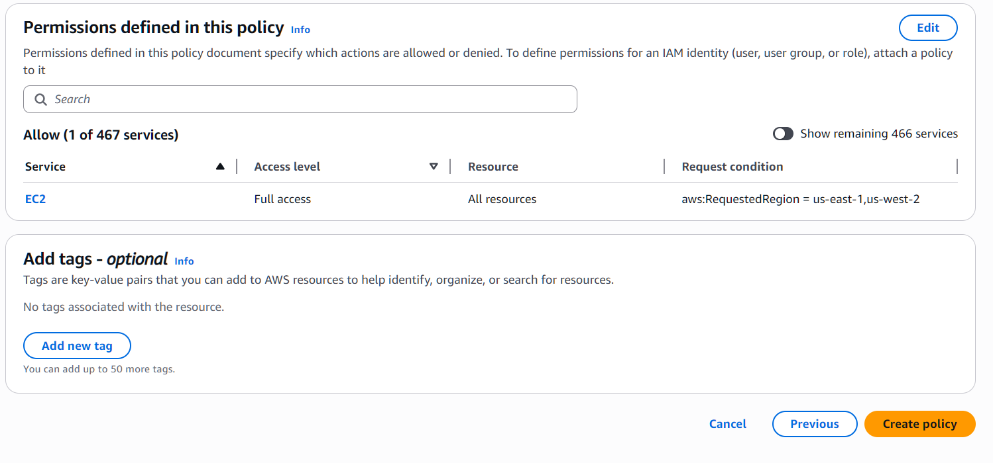
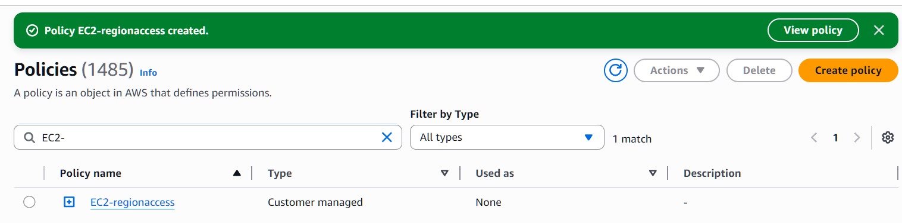
Added policy to the user I have created
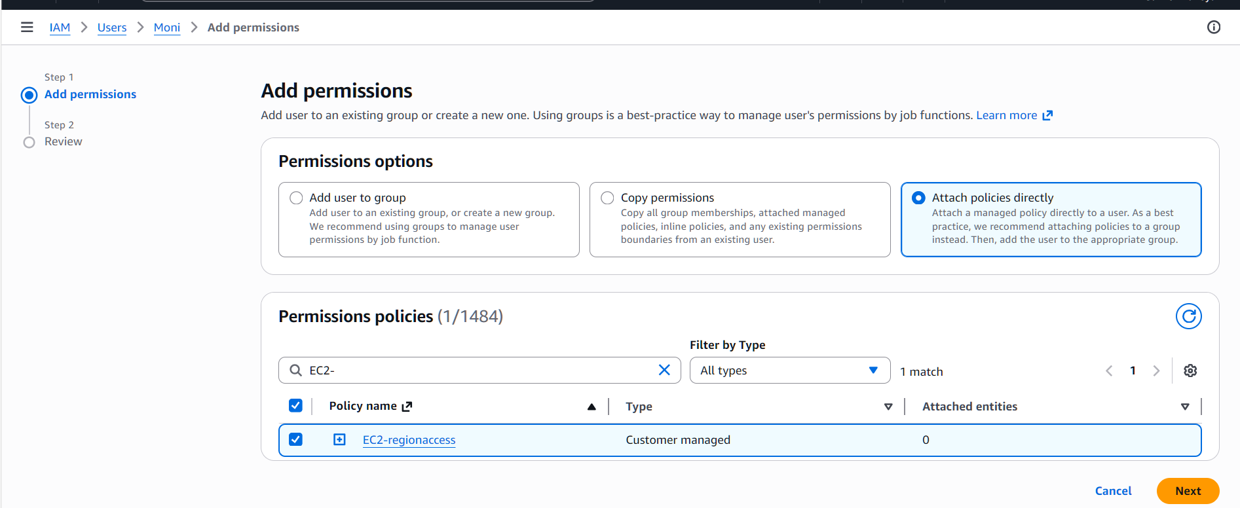
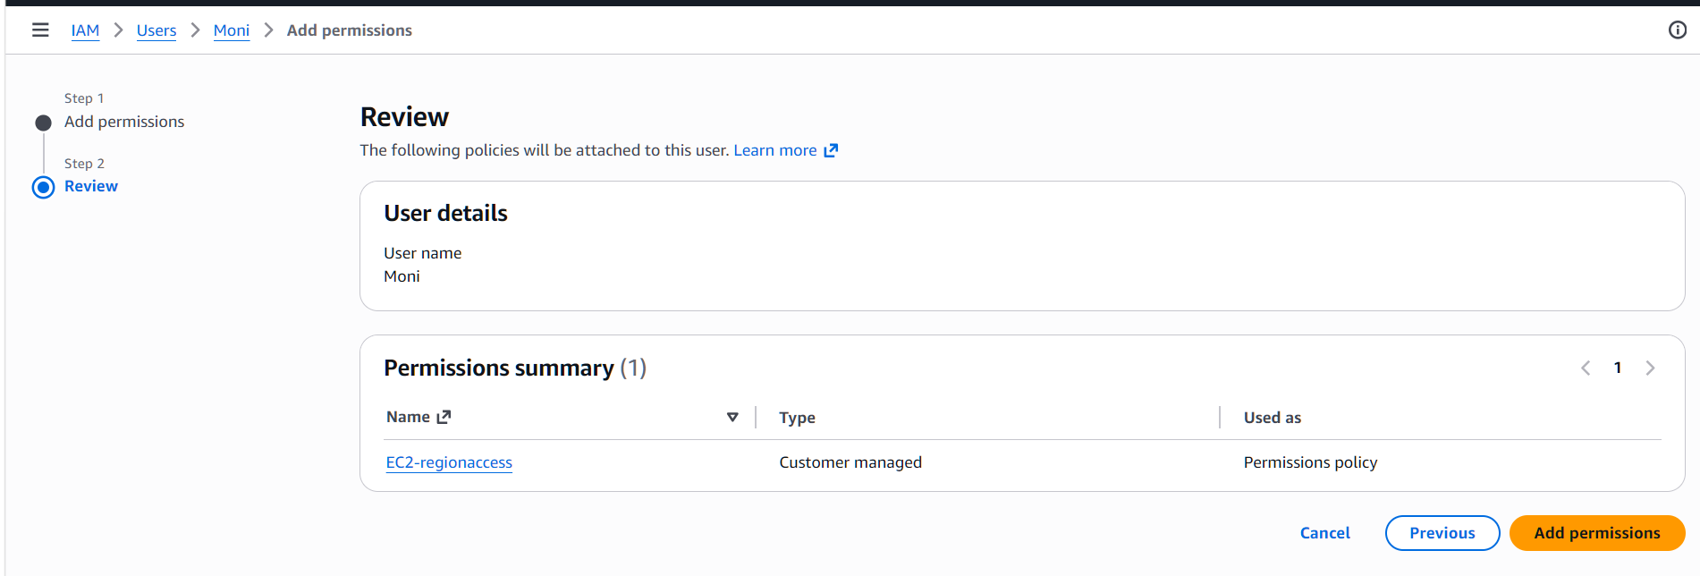
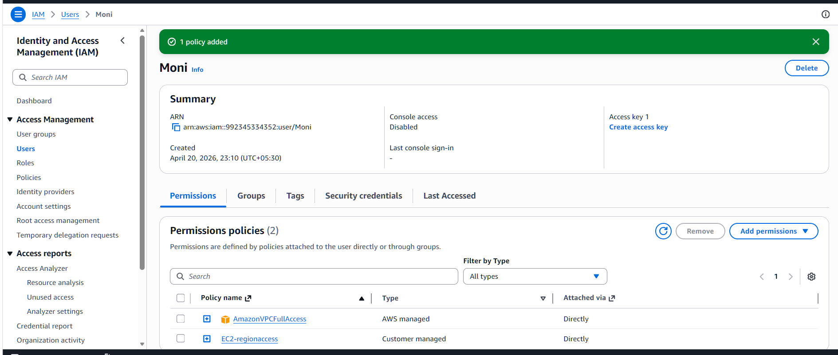
6) We have two accounts: Account A and Account B. Account A user should access an S3

bucket in Account B
I have added police by allowing account A to access my bucket
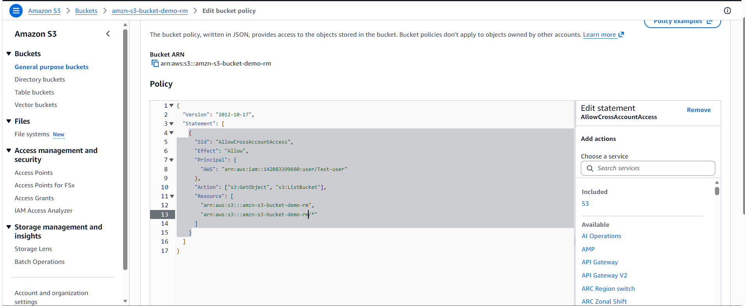
Accont A can access my s3 bucket
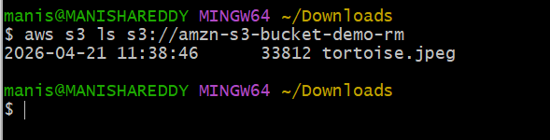
Here account A added a policy to access her s3 bucket
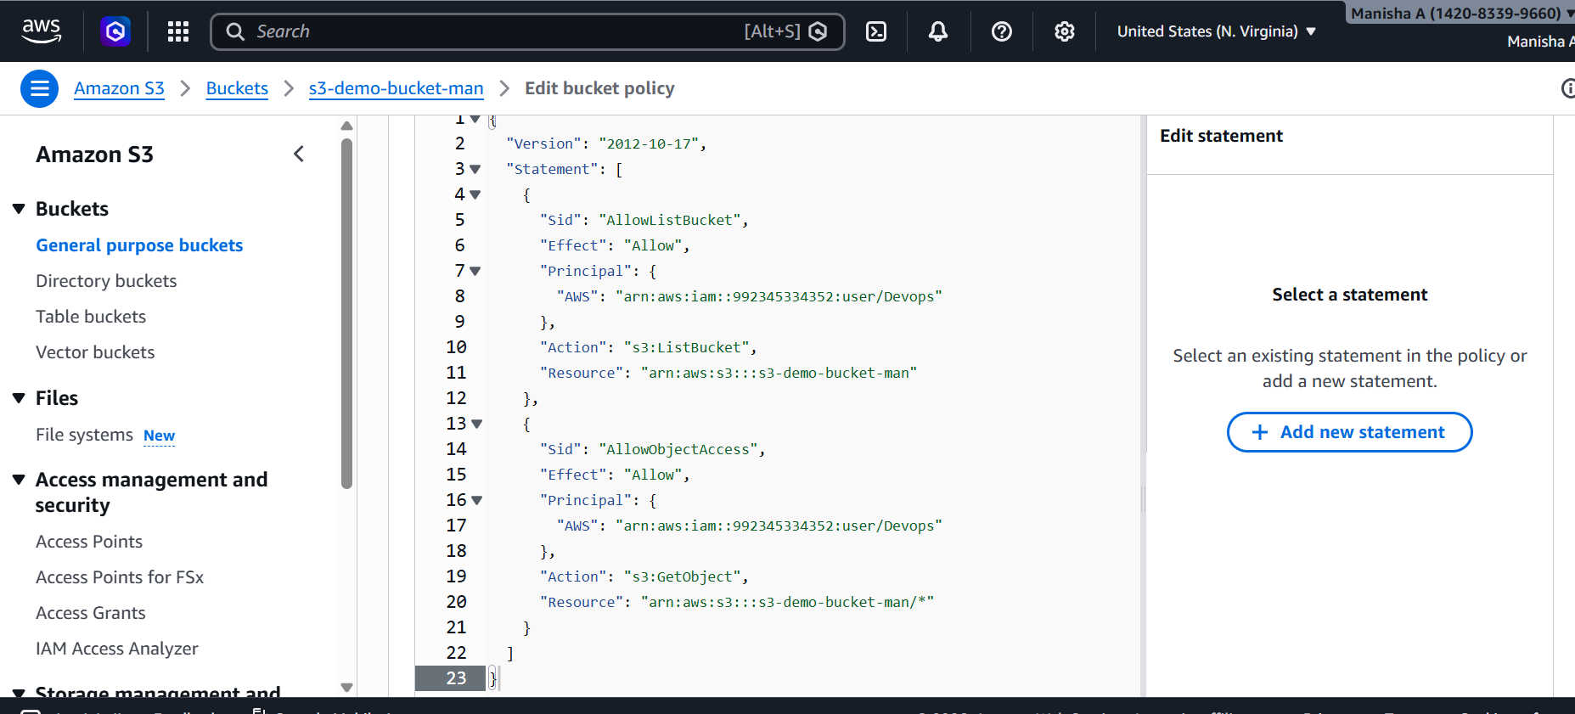

Here I can access account B s3 bucket
